**Task 1**

1] This command git –version will check the git version



2] This command git config –global user.name “Wasim Shaikh” will configure user name



3] This command git config –global user.email [wasim.shaikh15121984@gmail.com](mailto:wasim.shaikh15121984@gmail.com)



4] This command git status will show the files status

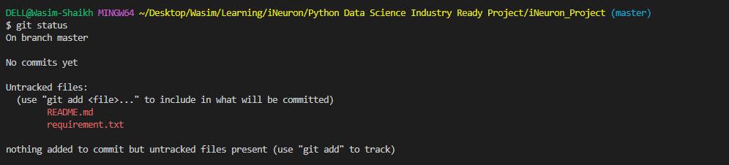

5] This command git add . all the files



6] This command git branch will show the existing branch



7] This command git branch –M main change the branch name to main



8] This command git remote –v will show whether to fetch or push



9] This command git push origin main will add the files

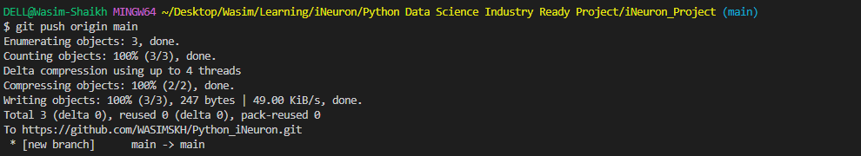

10] This command will git push origin main show updates status



11] This command git branch developer1 will add new branch



12] This command git checkout developer1 will switch the branch from main to developer1



13] This command git commit –m “This is my second commit”



14] This command git merge developer1 will add all the new changes to main branch

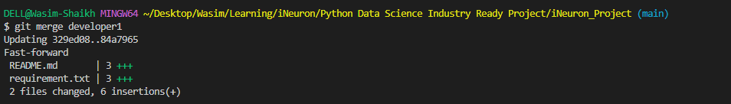

15] This command git push origin main will update the main branch

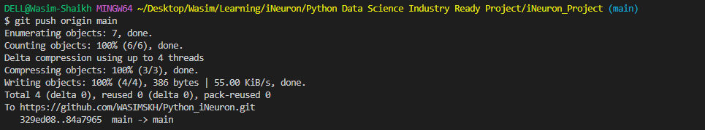

**Task 2**

1] Proper open source structure

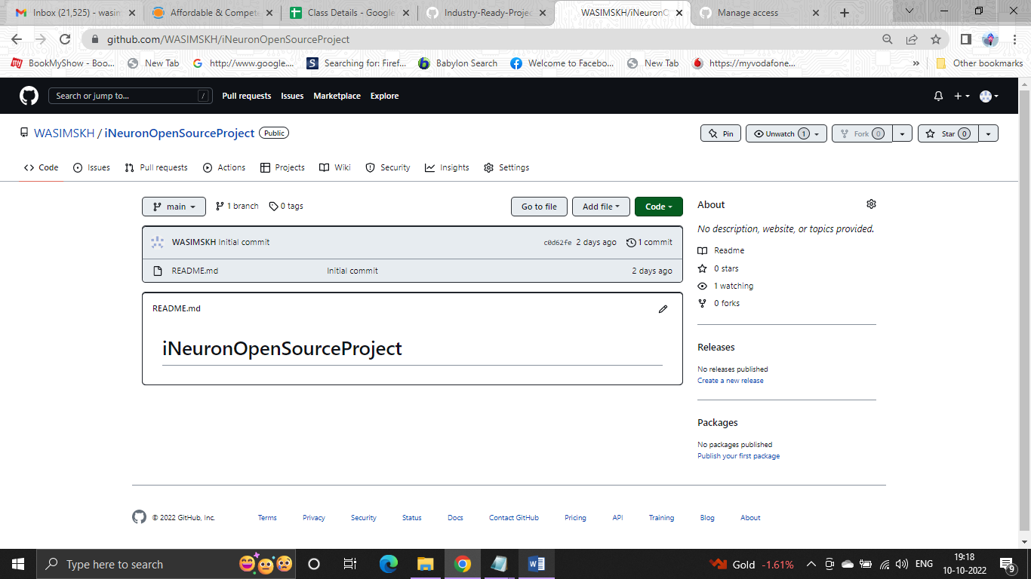

2] Proper Readme

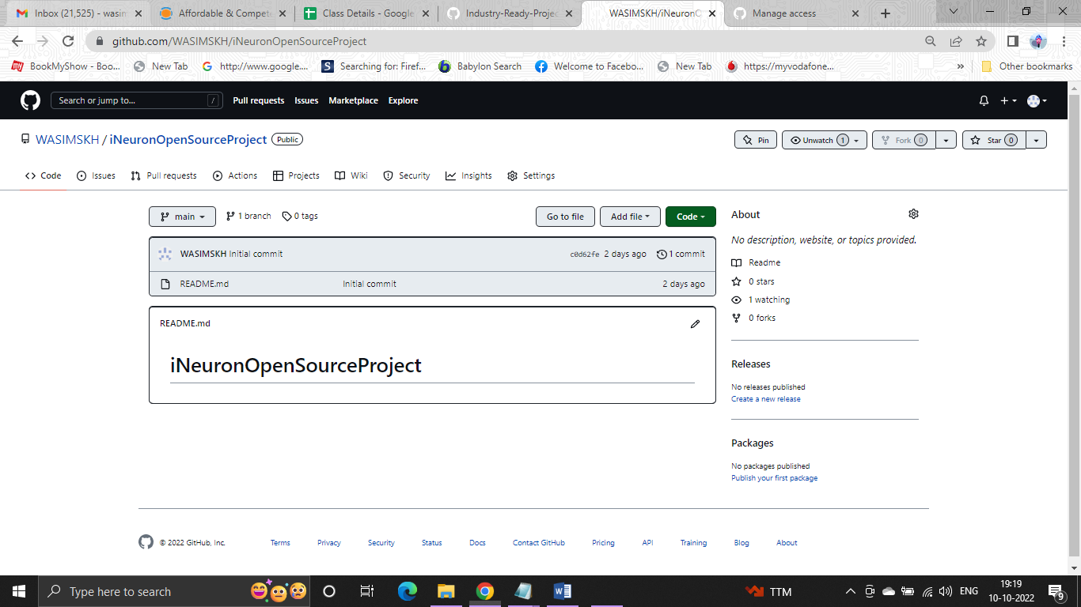

3] Add 2 Collaborator

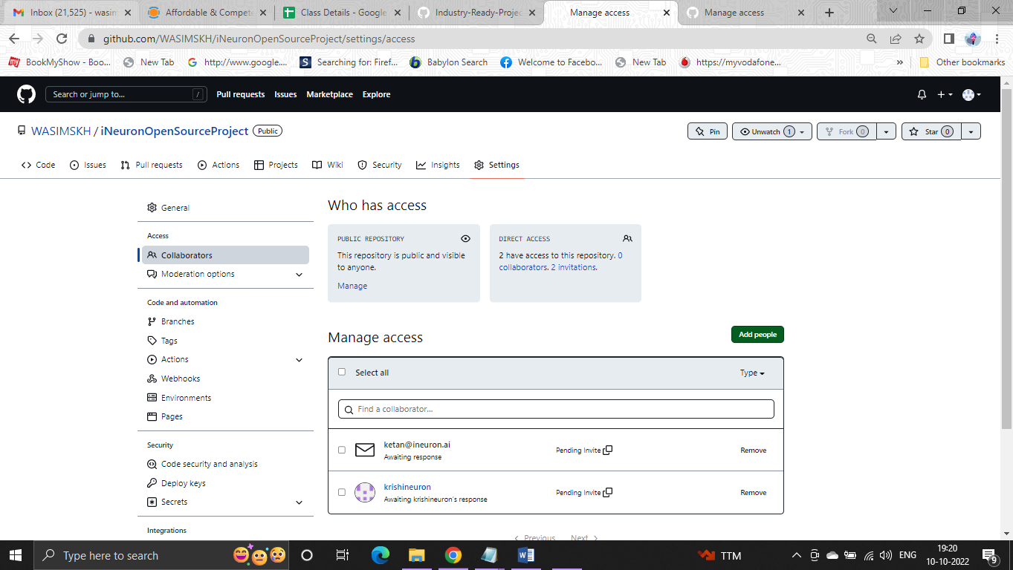

**Task 3**

1] Create a Issue in your github repository.

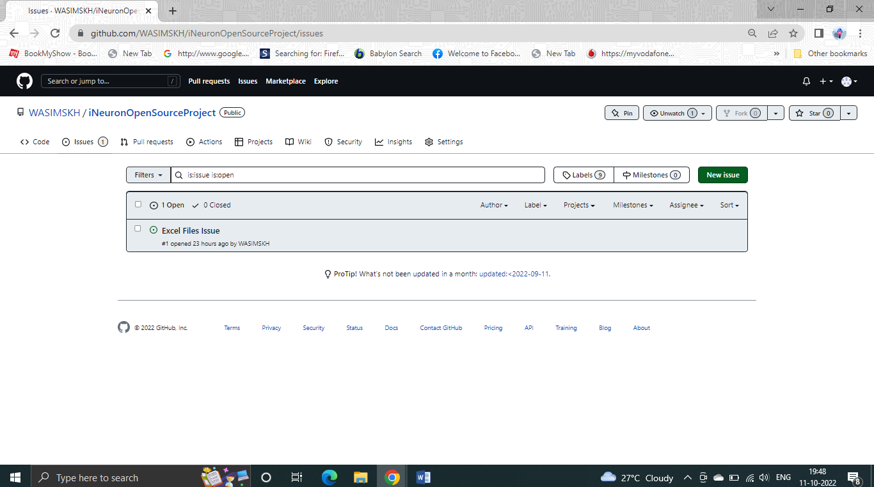

2] Raise a pull request.

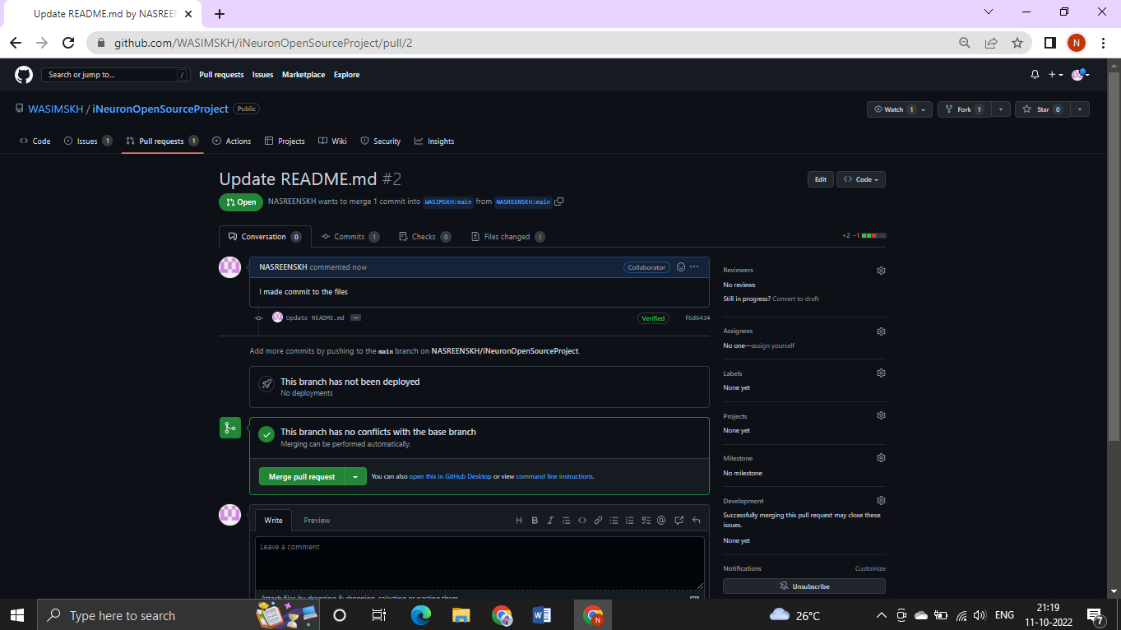

3] Merge A pull request.

